**WEEK 4 – MORE QUERIES ON BANK DATABASE**

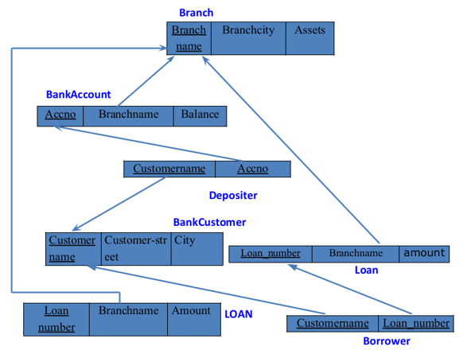

**Create Borrower table by specifying the primary keys and foreign keys.**

create table Borrower(

Customername varchar(20),

Loan_number int,

foreign key(Customername) references BankCustomer(Customername),

foreign key(Loan_number) references Loan(Loan_number)

);

**Insert values into the Borrower table. (INSERTION)**

insert into Borrower values("Avinash",1);

insert into Borrower values("Dinesh",2);

insert into Borrower values("Mohan",3);

insert into Borrower values("Nikil",4);

insert into Borrower values("Ravi",5);

**Extra insert queries.**

insert into branch values("SBI_MantriMarg","Delhi",200000);

insert into BankAccount values(12,"SBI_MantriMarg",2000);

insert into Depositer values("Nikil",12);

**Select new table. (SELECTION)**

select * from Borrower;

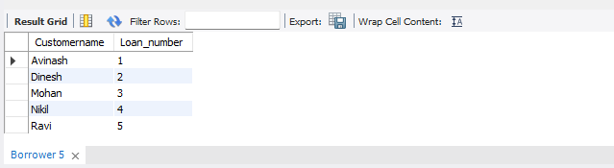

**QUERIES**

1. **Find all the customers who have an account at all the branches located in a specific city (Ex. Delhi).**

select d.Customername from branch b, Depositer d, BankAccount ba where

b.Branch_city='Delhi' and d.Accno=ba.Accno and b.Branch_name=ba.Branch_name

group by d.Customername having count(distinct b.Branch_name)= (select count(distinct b.Branch_name) from branch b where b.Branch_city='Delhi’;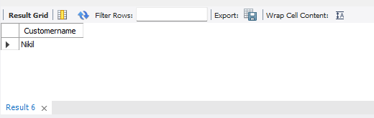

1. **Find all customers who have a loan at the bank but do not have an account.**

select distinct b.Customername from Borrower b, Depositer d

where b.Customername NOT IN(

select d.Customername from Loan l,Depositer d, Borrower b

where l.Loan_number=b.Loan_number and d.Customername=b.Customername

);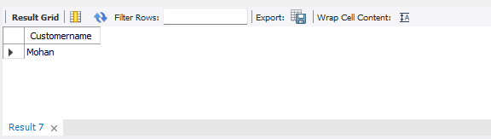

1. **Find all customers who have both an account and a loan at the Bangalore branch.**

select distinct d.Customername from Depositer d

where d.Customername IN(

select d.Customername from branch br,Depositer d, BankAccount ba

where br.Branch_city='Bangalore' and br.Branch_name=ba.Branch_name

and ba.accno=d.accno and Customername IN(

select Customername from Borrower)

);

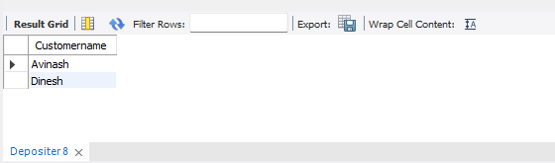

1. **Find the names of all branches that have greater assets than all branches located in Bangalore.**

select b.Branch_name from Branch b

where b.assets> ALL (

select SUM(b.assets) from Branch b

where b.Branch_City='Bangalore' );

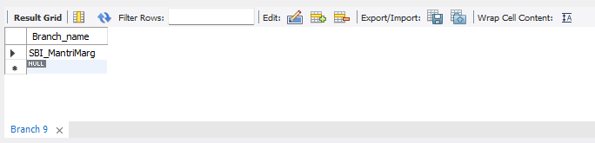

1. **Update the Balance of all accounts by 5%**

UPDATE BankAccount set Balance=(Balance + (Balance*0.05));

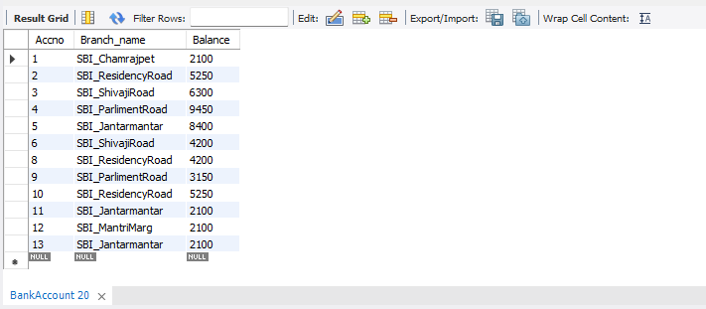

1. **Demonstrate how you delete all account tuples at every branch located in a specific city (Ex. Bombay).**

delete ba.* from BankAccount ba, branch b where branch_city='Bombay' and ba.Branch_name=b.Branch_name;

select * from BankAccount;

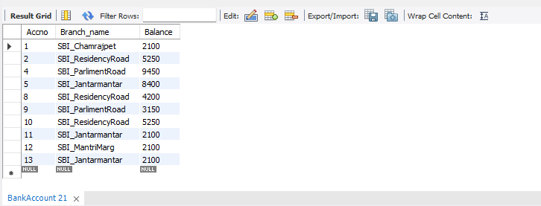

**SPOT QUERY: Demonstrate how to delete all the branches located in Bangalore**

delete b.* from branch b where Branch_city=’Bangalore’;

select * from branch;

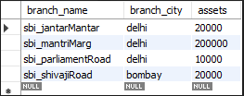

select * from BankAccount;

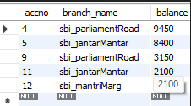

select * from Loan;

